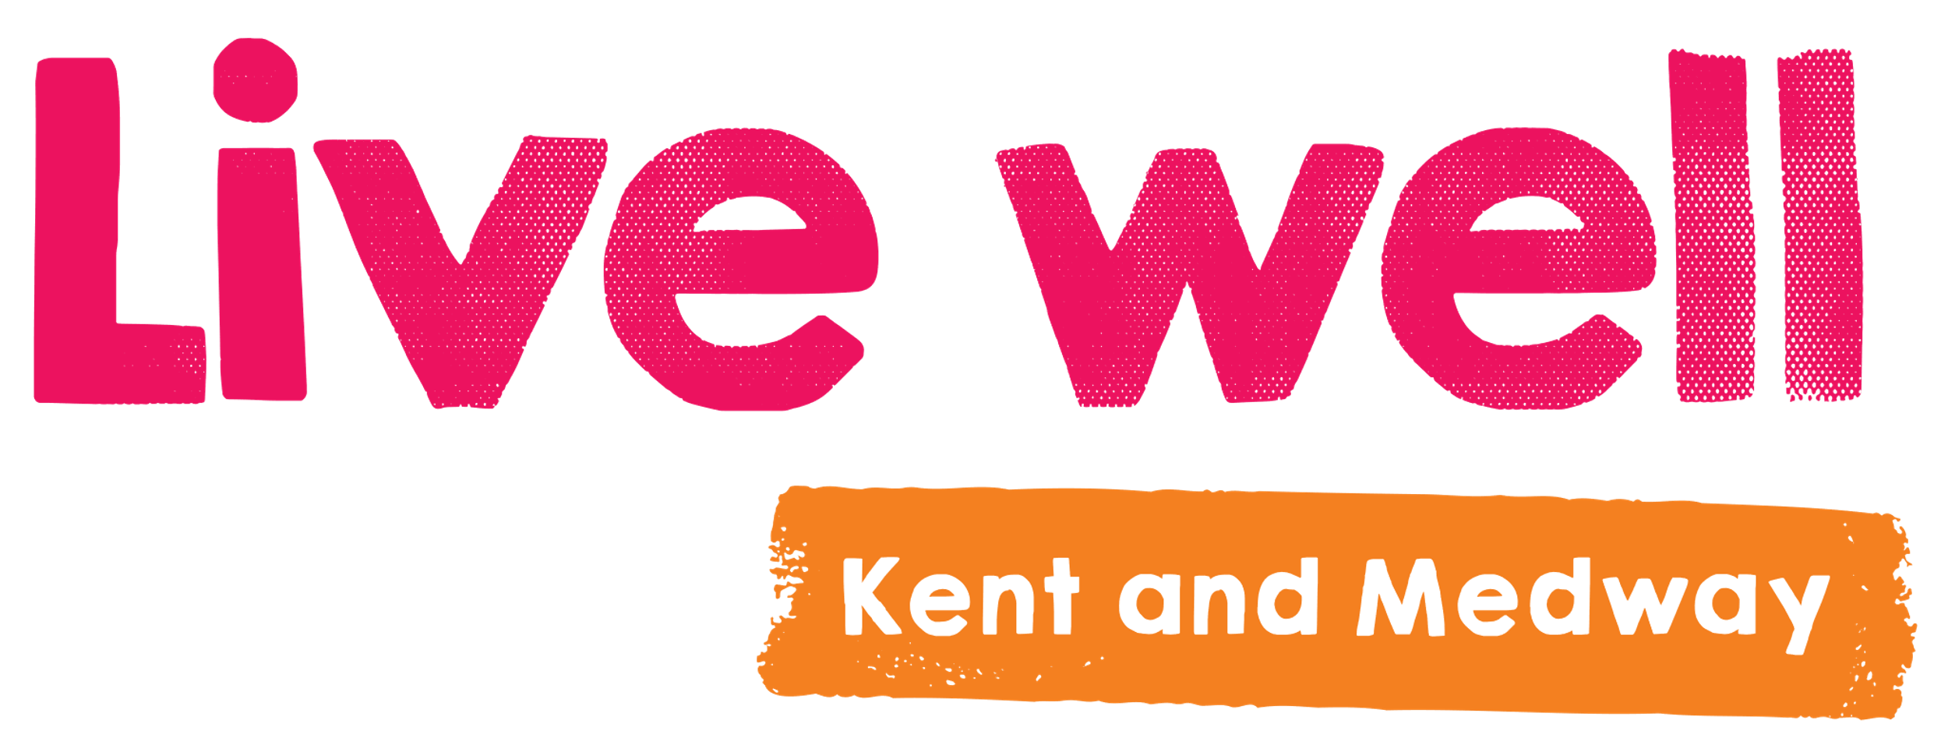

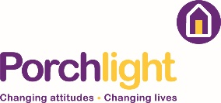
Live Well Kent and Medway Innovation Fund 2021/22
Application Form

Please carefully read the guidance notes before completing the application form.

General Details
Group/organisation
Name of group/organisation:
Address:
Postcode:
Telephone:
Email:
Contact details
Contact person for this application from your organisation and their details:
Position/job role:
Email:
Telephone:
Organisational Structure
Does your group/organisation have a legal or constituted structure (‘x’ relevant box)
No Yes (If ‘yes’ please describe briefly, e.g. ‘we are a charity’.)

Please provide your group or organisation’s company or charity number (if applicable):
How long has your group/organisation been established for? (‘x’ relevant box)
0-2 yrs 2-4 years 4+ years
Please give a brief description of your group or organisation’s purpose and aims:

Project Proposal
What is your project name?
List below who will be involved in the delivery of activities or anyone who will be supporting / collaborating with you. You can include staff names and roles, where appropriate.

How many people will your project work with?

Describe your project. How do you know there is a need for the project and were people with mental health issues involved in the design? (250 words limit)

What are you hoping to achieve through the project (its aims) and how will you do this (objectives/activities), and over what time period? (250 words limit)

Which Live Well Kent outcomes will your project support? You need to meet one or more outcomes. Points are awarded for how well your project supports these outcomes. (250 words limit)

How and why is your project/initiative innovative? We are either looking for new ideas or projects, or for new ways of delivering or developing support, which may build on existing work. We will not fund existing services or projects where there is no evidence of innovation. (500 words limit)

Financial Information
What is the total cost of the project?
How much are you requesting from the Live Well Kent Innovation Fund?
How much match funding do you have already (if any) and who from? (include materials, venue or time you or others will give)? (Match funding is not essential but can help to show value for money).

Breakdown of total project costs/budget
Action/Item | Amount | Funder | Secured Y/N

Cost per participant/service users = (Project total amount divided by number of participants/service users)
£

Signed on behalf of the Group/Organisation
Name: Position:
Signed: Date:

Please email your completed application to innovation@porchlight.org.uk by Monday 10th January 2022 by 9am.

Organisations being awarded an Innovation Fund grant will be notified by 17th January 2022 and grant agreements will be issued in January. The projects will start on 1st March 2022.

