Road to Recovery November Courses and Workshops

17, St Johns Road, Margate, Kent, CT9 1LU Telephone: 01843 280022 Email: info.thanet@richmondfellowship.org.uk

Working towards a society that values and promotes good mental health and well-being for all

Welcome to our Road to Recovery Programme, we hope you will find the following information helpful in learning how Richmond Fellowship are supporting people with mental health problems in Thanet.

The support we give, for a period of up to one year, includes the following:

An opportunity to work on a one to one basis with a Community Link Worker to develop a personalised support and recovery plan

Access to a range of Road to Recovery Workshops and Courses including: Anxiety Management, Positive Thinking, Making Every Moment Count, Assertiveness and Effective Communication

Information and sign-posting to other services and activities available within the community, including social and leisure activities, education and training

Support to develop a fulfilled and healthy social life, to make new friends, to build self-confidence, to improve self esteem and to achieve new skills

Sharing mental health information with relatives and friends to increase and enhance an understanding of personal support needs

Workshops, Courses and Meetings – November 2017

Event
Brain Training Workshop | Monday 6th  1pm - 2. 45pm | Monday 13th  1pm - 2. 45pm | NO EVENT | Monday 27th  1pm - 2. 45pm
Assertiveness Course | Thursday 9th  1pm – 2.45pm | Thursday 16th  1pm – 2.45pm | Thursday 23rd  1pm – 2.45pm | Thursday 30th  1pm – 2.45pm
Peer Led Activity | NO EVENT | TBC  Monday 13th  10.30am – 12pm | NO EVENT | TBC  Monday 27th  10.30am – 12pm
Speak Up CIC User Forum “Drop In” | NO EVENT | Wednesday 8th  10.30am – 11.30am | NO EVENT | Wednesday 22nd  10.30am – 11.30am
Peer Leaders Focus Group | 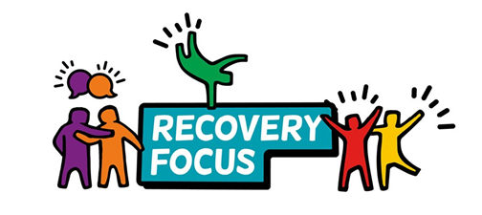  Wednesday 1st  1pm – 2.45pm | NO EVENT | Wednesday 15th  1pm – 2.45pm | NO EVENT

All workshops and courses are SPACE LIMITED

Please contact us to find out more details or to book your place

Richmond Fellowship (Thanet Community Service) is part of the Live Well Kent partnership. www.livewellkent.org.uk email:info@livewellkent.org.uk

All workshops and courses are SPACE LIMITED

Please contact us to find out more details or to book your place

Further Details of Courses & Workshops

Brain Training Workshops

By utilising puzzles, riddles and games we will work on improving cognitive processes such as memory, attention, speed of processing and problem solving.

Assertiveness Course

Assertiveness is the ability to communicate opinions, thoughts, needs and feelings in a direct, honest and appropriate manner. This course strives to provide you with the tools and techniques necessary to improve your Assertiveness through open discussion and focused activity. This course covers the different communicative styles whilst assisting you to identify your own; allowing you to find your strengths and areas for improvement.

Further Details of Meetings

Speak Up CIC User Forum Drop In

These forums are once a fortnight and designed to allow service users from to provide their feedback regarding services across Thanet.

Peer Leader Focus Group

We hold bi-weekly meetings with our volunteer Peer Leaders to discuss current workshops, fundraising, community events and new workshop development. To attend these meetings is it necessary to have completed the Richmond Fellowship ‘Peer Leader’ Training Course. For details of the next available course, please ask your Community Link Worker.

Peer Led Activities

Friday Social Group

Each Friday ‘The Friends of Richmond Fellowship’ meet at the Elm’s Club Ramsgate to socialise, play pool or partake in the Sign Language Course hosted by one of our volunteers. If you are interested in attending, let a member of staff know to ensure one of our Peer Leaders is available to greet you.

